UNIVERSITY OF MALAYA

EXAMINATION FOR THE DEGREE OF MASTER OF DATA SCIENCE

ACADEMIC SESSION 2017/2018 : SEMESTER I

WQD7001 : Principles of Data Science

Jan 2018 Time : 2 hours

INSTRUCTIONS TO CANDIDATES :

Answer **ALL** questions (50 marks).

(This question paper consists of 4 questions on 4 printed pages)

1. Exploratory analysis is largely concerned with summarizing and visualizing data before performing formal modelling.
2. Indicate **FOUR** purpose of exploratory data analysis.

[4 marks]

1. The snapshot of the dataset “mtcars” is shown in Figure 1 below.

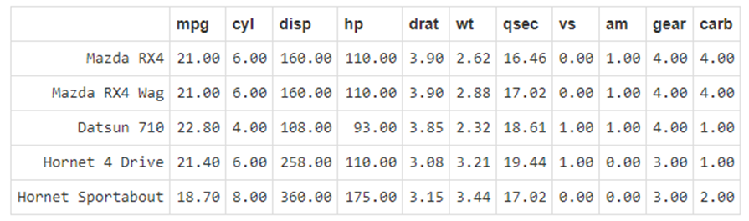

Figure 1 – mtcars dataset

Show how you would perform the following exploration and manipulation on the given dataset.

1. Lists names of variables in the dataset.

ii) Shows the number of rows/columns of the dataset.

iii) See a summary statistics of the Gross horsepower.

iv) Display the structure of the dataset.

v) Visually check possible correlated variables.

vi) Returns number of missing values in each variable of a dataset.

vii) Replace all the ‘am’ transmission variables with words representation. Transmission (0 = automatic, 1 = manual)

[8 marks]

1. Decide which descriptive statistics tool should you use according to the given situation.

|  |  |  |  |  |
| --- | --- | --- | --- | --- |
| **Data type** | **Objective** | **Example** | **Statistical tools** | **Graphical tools** |
| i.  Quantitative  One variable | Estimate a frequency distribution | How many students per batch fail to graduate on time? | **?** | **?** |
| ii. Quantitative  One variable | Measure the central tendency of one sample | What is the average grade in a course? | **?** | **?** |
| iii.  Quantitative  One variable | Measure the dispersion of one sample | How are the grades dispersed around the average grade in a course? | **?** | **?** |
| iv.  Quantitative  Two variables | Describe the association between two variables | Does plant biomass increase or decrease with soil Pb content? | **?** | **?** |
| v.  Qualitative (univariate analysis) | Detect the most frequent category | Which is the most frequent eye color in Malaysia? | **?** | **?** |

[8 marks]

1. a) Explain the problems reproducibility research **CAN** and **CANNOT** solve.

[6 marks]

b) Distinguish between weaving and tangling in literate programming.

[4 marks]

3. a) Machine learning is not a solution for every type of problem. There are certain

cases where robust solutions can be developed without using ML techniques.

Discuss **TWO** situations where machine learning is useful.

[4 marks]

b) Formal ML is defined as : A computer program is said to learn from experience E, with respect to some task T, and some performance measure P, if its performance on T as measured by P improves with experience E.

Suppose your email program watches, which emails you, do or do not mark as spam, and based on that learns how to better filter spam.

What is the task **T**, experience **E** and performance measure **P** in this setting?

[3 marks]

c) How would you write a program to distinguish a picture of yourself from a picture of someone else?

[3 marks]

4. The phrase “data storytelling” has been associated with many things - data visualizations, infographics, dashboards, data presentations, and so on. Too often data storytelling is interpreted as just visualizing data effectively; however, it is much more than just creating visually-appealing data charts.

Present a **THREE** key elements structured approach of data storytelling for communicating data insights. Summarize your presentation with a diagram.

[10 marks]

**END**